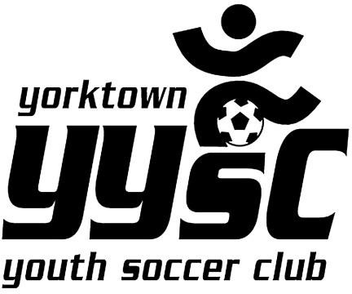LABOR DAY TOURNAMENT 2024

Business Sponsor Advertisement

Team Name/Sold by: _

Advertiser’s Name: _ _

Advertiser’s Phone

Advertiser’s Email: _ _



Charitable Donation:

A gift made by an individual or an organization to a nonprofit organization,

charity or private foundation. Charitable donations are commonly in the form of cash, but can also take the form of real estate, motor vehicles, appreciated securities, clothing

and other assets or services.

Dear Sponsor:

The Yorktown Youth Soccer Club will be hosting our Annual 2024 Labor Day Soccer Tournament. **We are asking you to support the YYSC Travel Teams by advertising with our club. Please choose one or more of the choices below:**

This year we will be offering the following: Please Circle:

**Choice 1-Email Blast**

Sponsor information will be sent to all YYSC families for the amount of time purchased

Please circle one:

# $300/3 months (3 blasts) $600/6 months (6 blasts) $900 / 1 year (12 blasts)

**Choice 2- Banner Options-**

**4x8 Banner of fence at tournament (2 days) $300 – (company supplies banner)**

**Choice 3- Website advertising**

Fixed logo on website

**$300/6 months $500 / 1 year**

# Donation: (please circle one) $50 $75 $100 $250 $500

mail to:

YYSC

1928 Commerce Street Yorktown Heights, NY 10598

Phone (914) 214-8118 Email [YYSC@VERIZON.NET](mailto:YYSC@VERIZON.NET)